“Genetical Characterization and Study of Bacteriophages against
strains causing respiratory infections’’

Grenoble University-Institute of structural biology

Student: Salome Barbakadze
Supervisor: Cecile Breyton

Grant donor: French-Georgian University

The aim of my research was to clean up bacteriophages from bacterial and medium proteins in order to sequence cleaned bacteriophages. During this project we also isolated and purified proteins from 4 phages and studied morphological properties of these phages. This project was a genetical part of my PhD work.
The goal of my PhD thesis is to refine technology of pastilles production containing bacteriophage cocktail against oral cavity infections and determine their antibacterial therapeutic effect. Pastilles could be considered as a phage depot, from where phages will be released periodically, that will prolong phage activity and make medicine more effective.
During my PhD study we received different strains of oral infections from diagnostic centers. We sequenced (3 Streptococcus, 4 Enterococcus, 2 Staphylococcus, 2 E-coli) strains. We studied sensitivity of those strains. After studying the antibiotic and phage sensitivity towards phages of our collection, 16 new phages were isolated.
Before doing this research I also studied biological properties of phages (Adsorption, cycle of single propagation, burst size...) and the influence of different environmental factors (pH, temperature, UV). We have also studied interaction between 2 Streptococcus, 2 Enterococcus bacteriophages and 1 Staphylococcus bacteriophage with pastille components (izomalt, gomiz, citric acid, cherry flavoring). We produced four experimental series in LTD ’’Neopharmi”. At the same time, I have studied bacteriophage activity in pastilles during a long period of time in order to choose the value of the preparation.
Methods used during this research:
- Separation of bacteriophage DNA - phage DNA separation by standard 20% SDS-0,5 MEDTA pH 8.0 solution [Bartlet.J 2018];
- Polyacrylamide Gel Electrophoresis “Phage ghost”-aim of this method is to get free phages from DNA/RNA and isolate proteins from phages [W.R Freeman and company 2007];
- Phage clean up-Dialysis – aim of this method is to clean-up bacteriophage from bacterial free proteins and medium proteins [ Fuenmayor J].

During this research we cleaned-up/purified 4 bacteriophages and studied their morphological properties. We also isolated proteins from these phages.

Clean-up and Purification of E-coli 108
We received two bands:
Upper band: Titre: 1x10⁴; Siphophages, head – 135x64,5nm, tail – 170,5x17,5nm
Lower band:Titre: 1x10⁴; Siphophages, head – 135x64,5nm, tail – 170,5x17,5nm
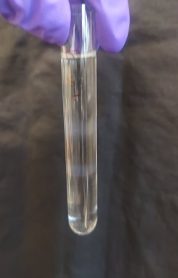 (lower band);

Clean-up and Purification of Staphylococcus aureus
We received two bands:
Upper band: empty siphophages, empty head 94 mn, free tail
181 nm
Lower band: siphophages head 77,5nm, tail 236 x 16,5nm
Titre: 1x10¹⁰

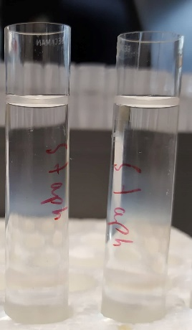 (lower band)

Clean-up and Purification of Streptococcus B:
We received two bands:
Upper band: Titre: 1x10⁸ ; Siphophages, head 114x57nm, Tail – 150x7nm
Lower band: Titre: 1x10⁸; Siphophages, head – 110,5; tail – 147nm

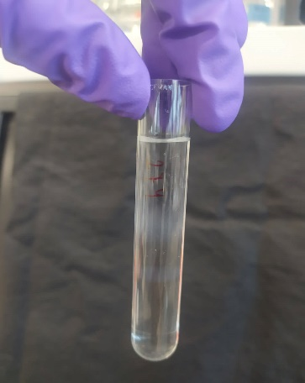 (lower band)

Clean-up and Purification of Enterococcus 201:
We received two bands:
Uper band: myoviridae capsids and empty myophages, head 84 nm, tail – 194,5x26nm
Lower band: Titre:1x10⁴; siphophages, head – 110x50 nm, tail – 150 x 10 nm

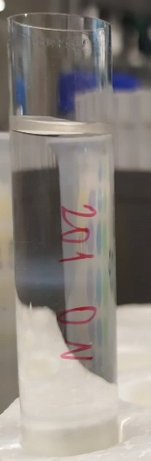 (lower band)
Fully phages are heavier than free phage tail and free head. That’s why we received higher titer and more clean phages in lower band.

We also isolated proteins from these four phages in order to determine size of proteins. We received the same 43 molecular weight size protein bands.

Electrophoresis separates proteins based on their size using electrical current

According to ISO standards genetical properties of bacteriophages and their host strains should be studied along with other characteristics. As it is known, temperate bacteriophage and lysogenic bacterial strains for treatment is unacceptable. That’s why we’re analyzing results of phages sequencing. For now, I’m analyzing my results and finalizing my thesis. The given results provide an opportunity to successful finish of my work.

